**Name**: Adwait S Purao  
**UID :** 2021300101  
**Batch :** B2

**Experiment No:** 4

**Aim:** To design and implement gate level and MSI Multiplexers and Demultiplexers

**Software Required:**

Proteus 8 Professional

1. IC7404 (NOT Gate)

2. IC4073 (3-input AND Gate)

3. IC4072 (4-input OR Gate)

4. IC74153 (Dual 1-of-4 Multiplexer)

5. IC74151 (1-of-8 Multiplexer)

6. IC74155 (Dual 2-Line To 4-Line Demultiplexers)

7. IC4052 (Dual 4-Channel Analog Multiplexer/ Demultiplexer)

8. Logic Toggle

9. Logic Probe

10. Ground

**Theory:**

***Multiplexer:***

Multiplexer means many into one. A multiplexer is a circuit used to select and route any one of the several input signals to a single output. A simple example of an nonelectronic circuit of a multiplexer is a single pole multi-position switch. Multiplexers can handle two type of data i.e., analog and digital. For analog application, multiplexer are built using relays and transistor switches. For digital application, they are built from standard logic gates. The multiplexer used for digital applications, also called digital multiplexer, is a circuit with many input but only one output. By applying control signals (also known as Select Signals), we can steer any input to the output. Some of the common types of multiplexer are 2-to-1, 4-to-1, 8-to-1, 16-to-1 multiplexer.

## 4×1 Multiplexer:

In the 4×1 multiplexer, there is a total of four inputs, i.e., A0, A1, A2, and A3, 2 selection lines, i.e., S0 and S1 and single output, i.e., Y. On the basis of the combination of inputs that are present at the selection lines S0 and S1, one of these 4 inputs are connected to the output. The block diagram and the truth table of the 4×1 multiplexer are given below

Block diagram and truth table

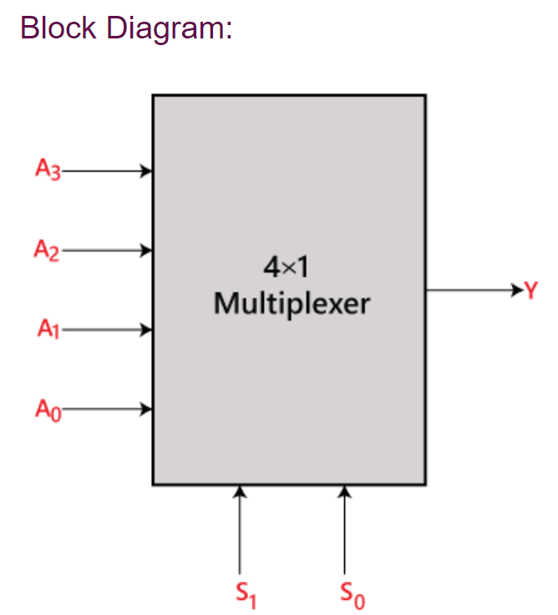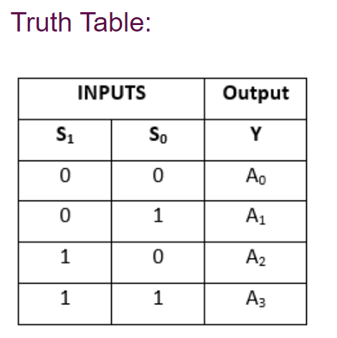

Logical circuit

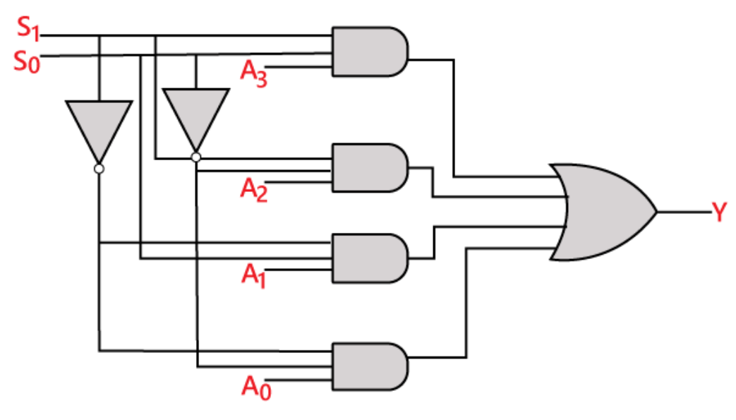

8 to 1 Multiplexer

In the 8 to 1 multiplexer, there are total eight inputs, i.e., A0, A1, A2, A3, A4, A5, A6, and A7, 3 selection lines, i.e., S0, S1and S2 and single output, i.e., Y. On the basis of the combination of inputs that are present at the selection lines S0, S1,and S2, one of these 8 inputs are connected to the output. The block diagram and the truth table of the 8**×**1 multiplexer are given below.

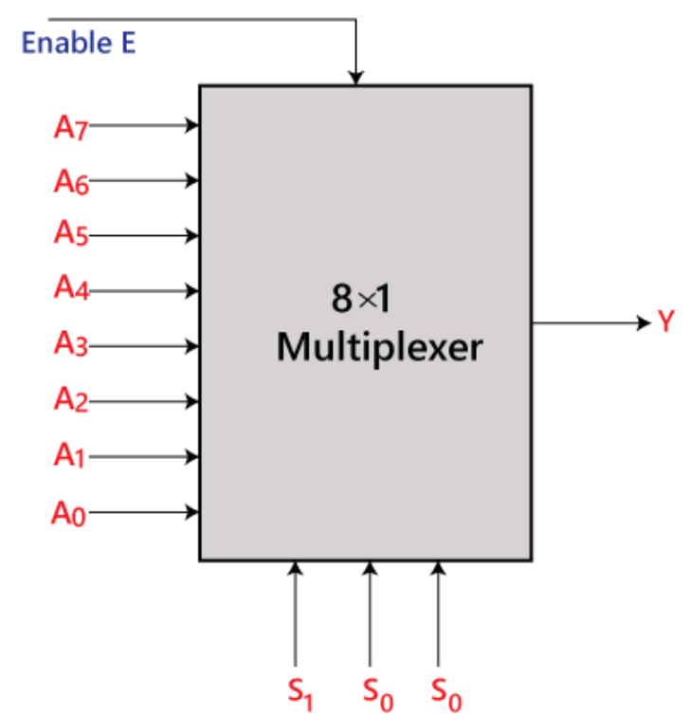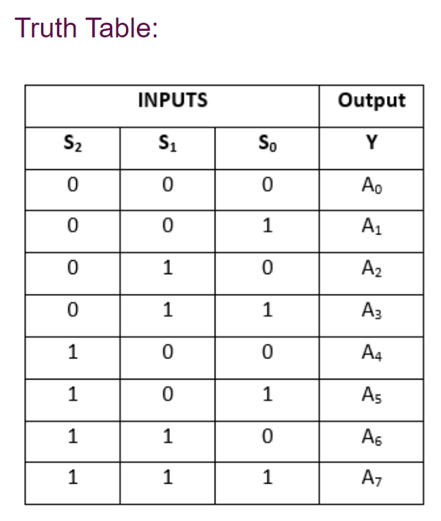

Logical circuit

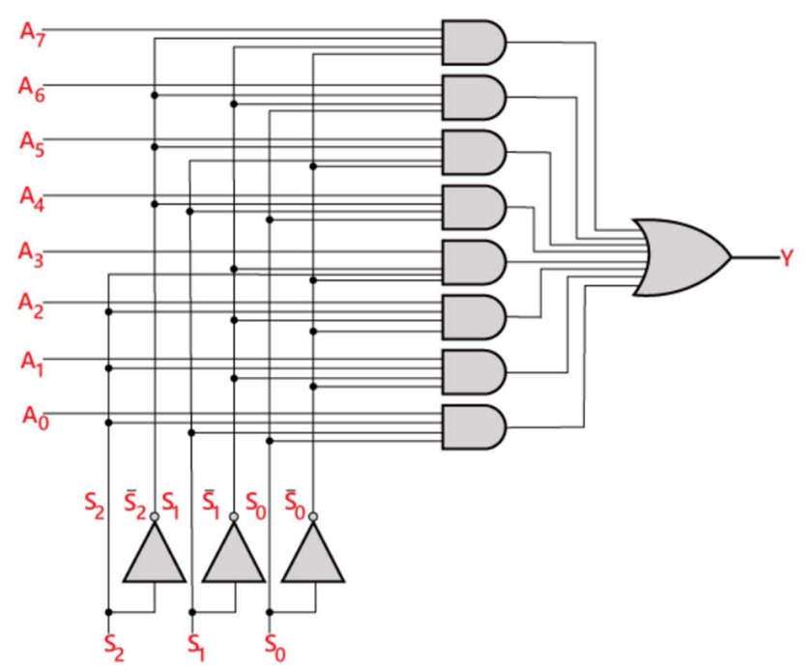

***Applications of Multiplexers:***

Multiplexer are used in various fields where multiple data need to be transmitted using a single line. Following are some of the applications of multiplexers –

1. ***Communication System*** – Communication system is a set of system that enable communication like transmission system, relay and tributary station, and communication network. The efficiency of communication system can be increased considerably using multiplexer. Multiplexer allow the process of transmitting different type of data such as audio, video at the same time using a single transmission line.

2. ***Telephone Network*** – In telephone network, multiple audio signals are integrated on a single line for transmission with the help of multiplexers. In this way, multiple audio signals can be isolated and eventually, the desire audio signals reach the intended recipients.

3. ***Computer Memory*** – Multiplexers are used to implement huge amount of memory into the computer, at the same time reduces the number of copper lines required to connect the memory to other parts of the computer circuit.

4. ***Transmission from the Computer System of a Satellite*** – Multiplexer can be used for the transmission of data signals from the computer system of a satellite or spacecraft to the ground system using the GPS (Global Positioning System) satellites.

***Demultiplexers:***

Demultiplexer means one to many. A demultiplexer is a circuit with one input and many outputs. By applying control signal, we can steer any input to the output. Few types of demultiplexer are 1-to 2, 1-to-4, 1-to-8 and 1-to 16 demultiplexer. Unlike encoder and decoder, there are n selection lines and 2n outputs. So, there is a total of 2n possible combinations of inputs. De-multiplexer is also treated as Demux.

***1 to 4 Demultiplexer***:

In 1 to 4 De-multiplexer, there are total of four outputs, i.e., Y0, Y1, Y2, and Y3, 2 selection lines, i.e., S0 and S1 and single input, i.e., A. On the basis of the combination of inputs which are present at the selection lines S0 and S1, the input be connected to one of the outputs. The block diagram and the truth table of the 1×4 multiplexer are given below.

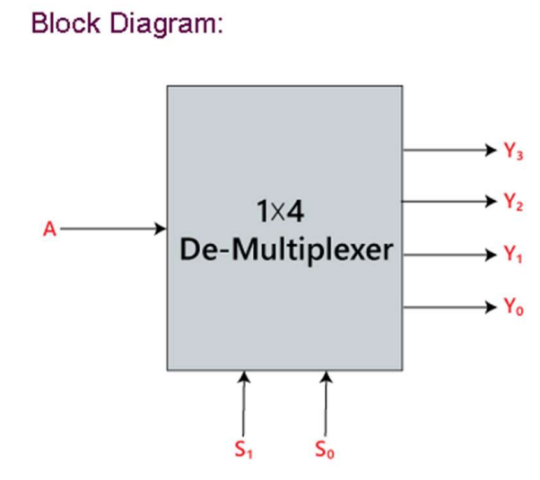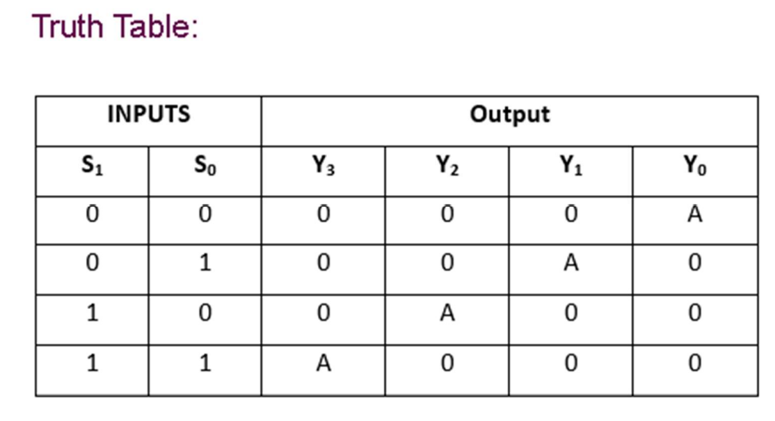

Logical circuit

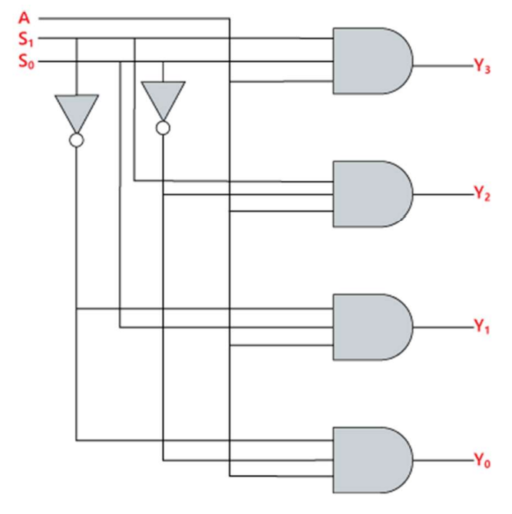

***1 to 8 Demultiplexer***:

In 1 to 8 De-multiplexer, there are total of eight outputs, i.e., Y0, Y1, Y2, Y3, Y4, Y5, Y6, and Y7, 3 selection lines, i.e., S0, S1and S2 and single input, i.e., A. On the basis of the combination of inputs which are present at the selection lines S0, S1 and S2, the input will be connected to one of these outputs. The block diagram and the truth table of the 1×8 de-multiplexer are given below

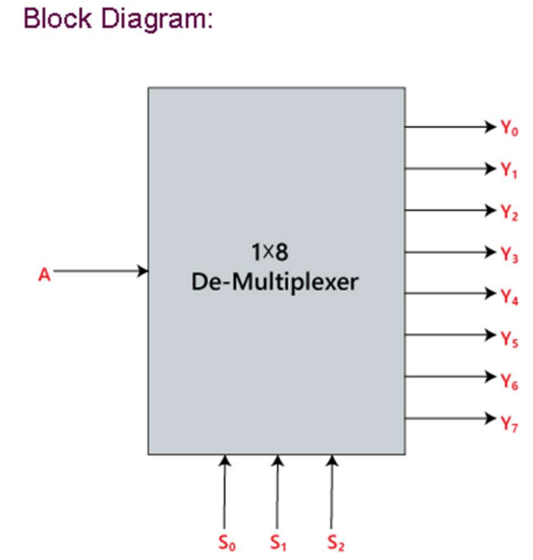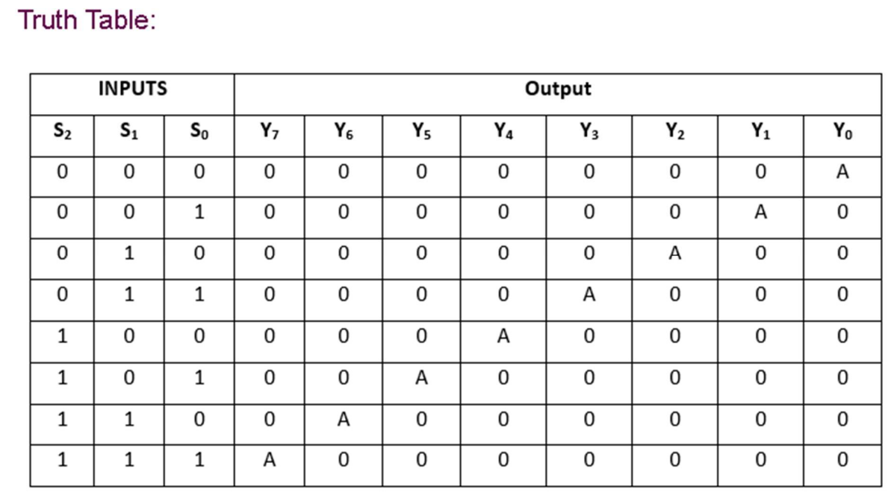

Logical circuit

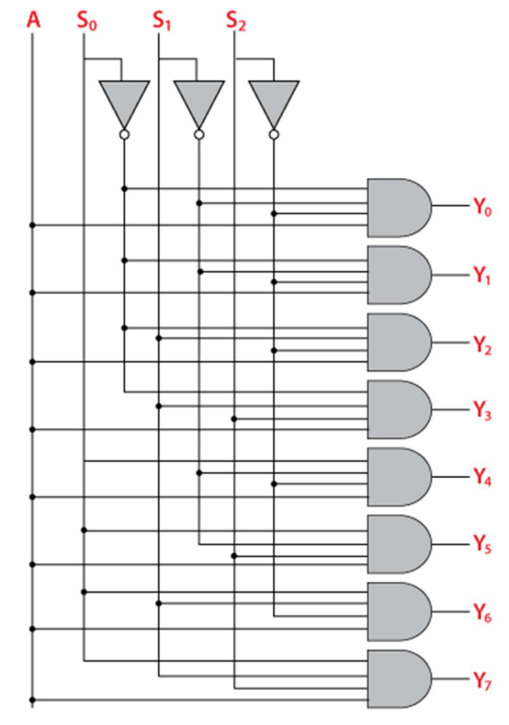

***Applications of Demultiplexer***:

1. ***Demultiplexer is used to connect a single source to multiple destinations***. The main application area of demultiplexer is communication system, where multiplexers are used. Most of the communication system are bidirectional i.e., they function in both ways (transmitting and receiving signals). Hence, for most of the applications, the multiplexer and demultiplexer work in sync. Demultiplexer are also used for reconstruction of parallel data and ALU circuits.

2. ***Communication System*** – Communication system use multiplexer to carry multiple data like audio, video and other form of data using a single line for transmission. This process make the transmission easier. The demultiplexer receive the output signals of the multiplexer and converts them back to the original form of the data at the receiving end. The multiplexer and demultiplexer work together to carry out the process of transmission and reception of data in communication system.

3. ***ALU (Arithmetic Logic Unit)*** – In an ALU circuit, the output of ALU can be stored in multiple registers or storage units with the help of demultiplexer. The output of ALU is fed as the data input to the demultiplexer. Each output of demultiplexer is connected to multiple register which can be stored in the registers.

4. ***Serial to Parallel Converter*** – A serial to parallel converter is used for reconstructing parallel data from incoming serial data stream. In this technique, serial data from the incoming serial data stream is given as data input to the demultiplexer at the regular intervals. A counter is attach to the control input of the demultiplexer. This counter directs the data signal to the output of the demultiplexer where these data signals are stored. When all data signals have been stored, the output of the demultiplexer can be retrieved and read out in parallel.

***Difference between Multiplexer and Demultiplexer:***

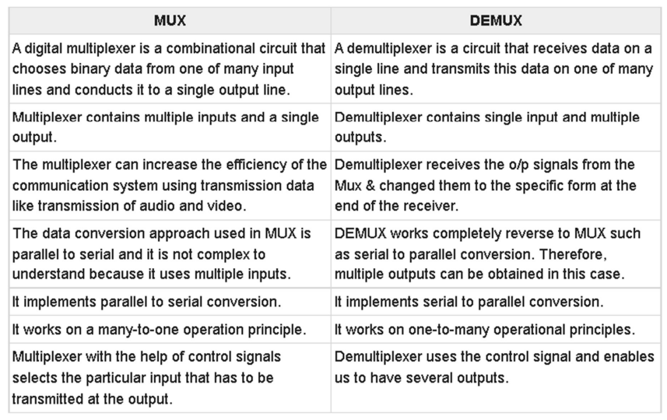

**Procedure:**

1. Create a new Project on Proteus 8 Professional.
2. Click on Schematic Capture.
3. On the left side of the screen click on P Symbol (Pick Devices), and add:

a. IC7404 (NOT Gate)

b. IC4073 (3-input AND Gate)

c. IC4072 (4-input OR Gate)

d. IC74153 (Dual 1-of-4 Multiplexer)

e. IC74151 (1-of-8 Multiplexer)

f. IC74155 (Dual 2-Line To 4-Line Demultiplexers)

g. IC4052 (Dual 4-Channel Analog Multiplexer/ Demultiplexer)

h. Logic Toggle

i. Logic Probe

4) On the leftmost corner, click on the terminals by clicking on the  icon and add a ground in the workspace.

5) Add all these components in their required amount in the workspace.

6)Join all the wires correctly as required.

7) Run the simulation by clicking on the  icon.

**Results and Observations:**

**1. 4:1 multiplxer using gates**

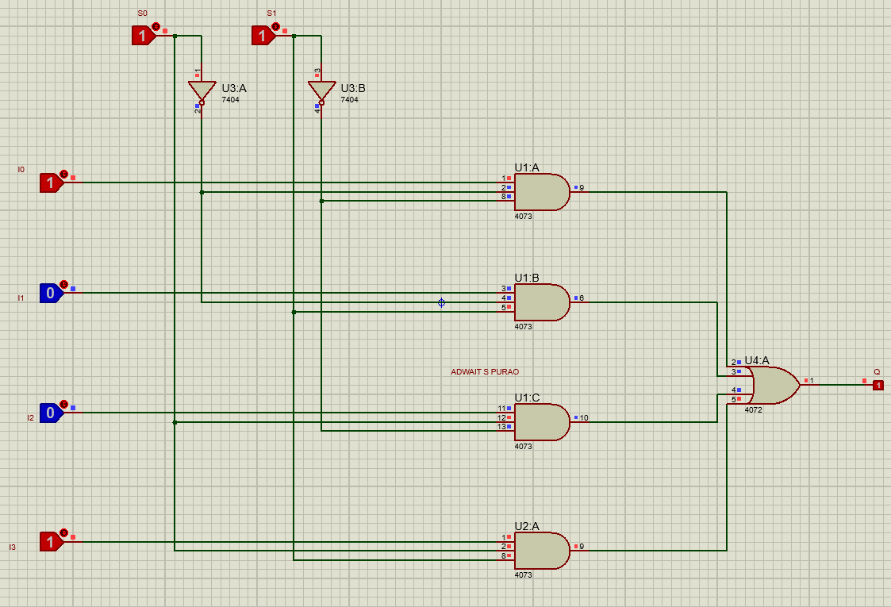

**2. 4:1 Mux using IC74153**

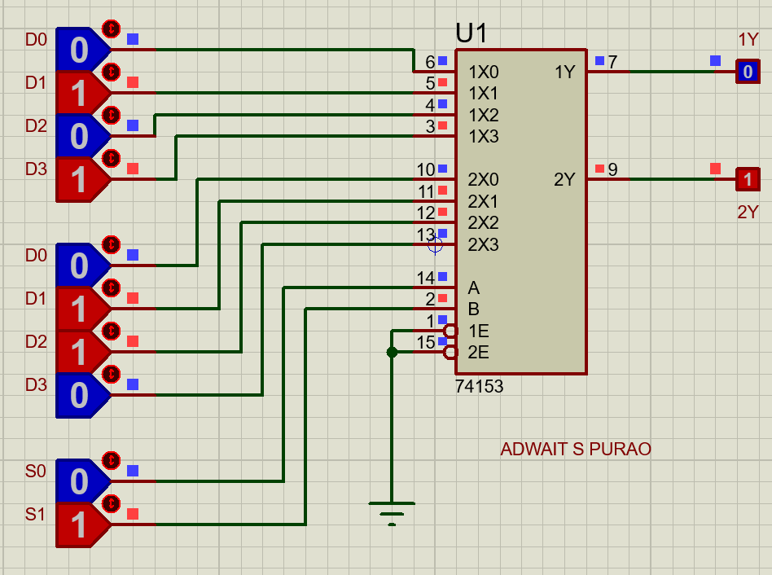

**3. 8:1 Multiplexer using IC 74151**

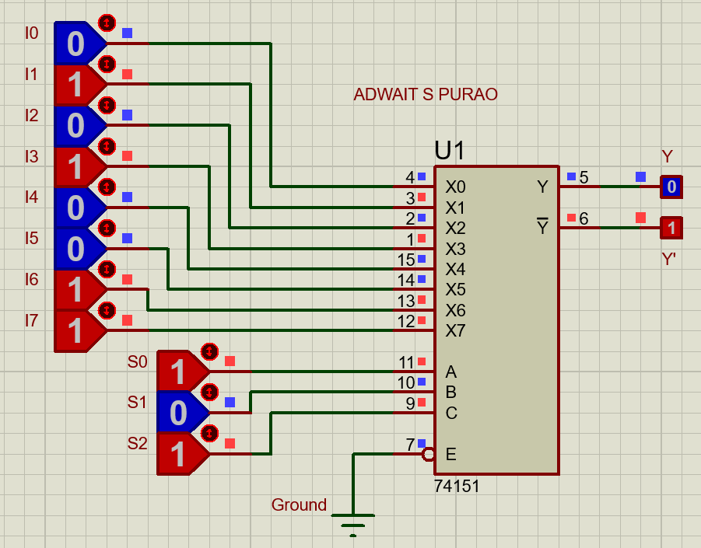

**4. 1:4 Demultiplexer using IC 74155**

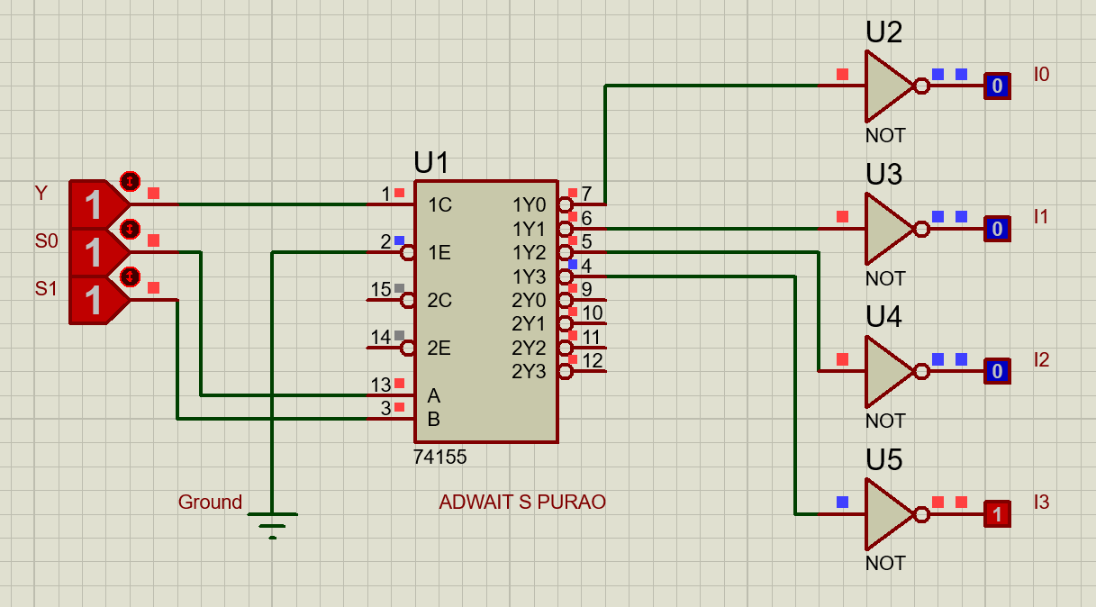

**5. Using IC 4052 to create 4:1 multiplexer**

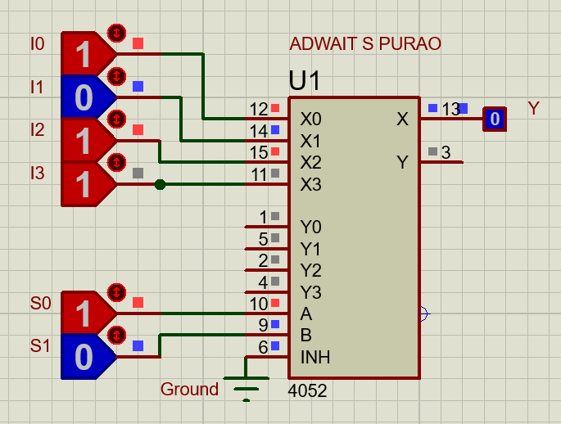

**6.Using IC 4052 for creating 1:4 Demultiplexer**

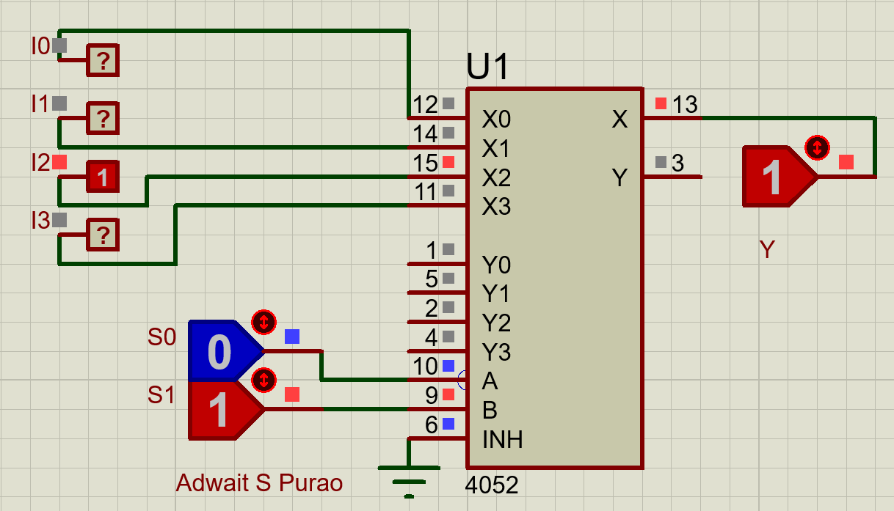

**Problem Statement:**

**Realize the logic function of the truth table given below:**

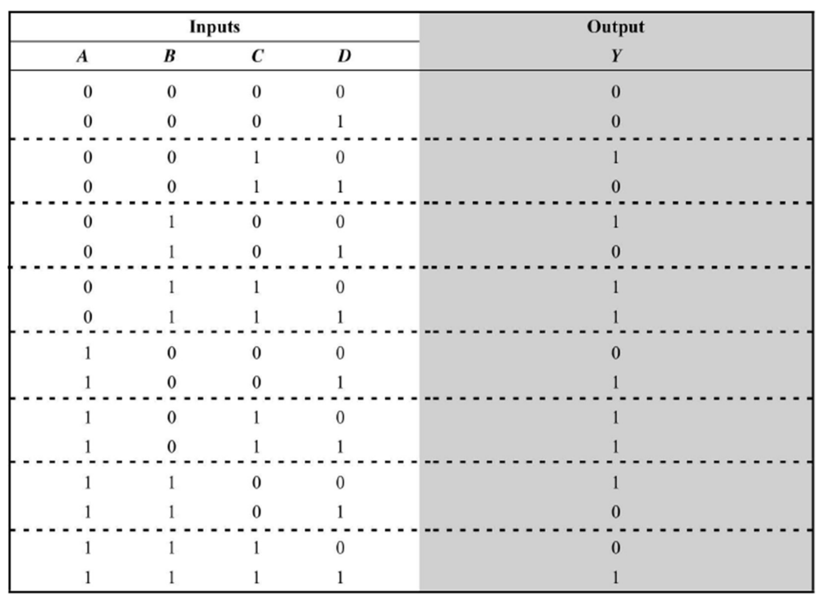

**Solution:**

A four variable truth table or logic expression can be realised using an 8:1 Multiplexer instead of a 16:1 Multiplexer. For this, partition the truth table as shown by the dotted lines. Here the inputs A, B and C are connected to the select inputs S2, S1, and S0 respectively. Now, we observe the relationship between input D and output Y for each group of 2 rows. There are four possible values of Y: 0, 1, D and D’. We note the output Y for each of the combinations of A, B and C, and then make the connections accordingly. The implementation of this function using an 8:1 Multiplexer is shown below.

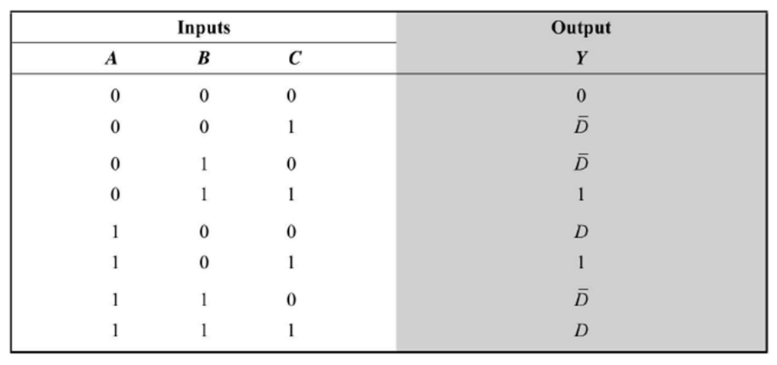

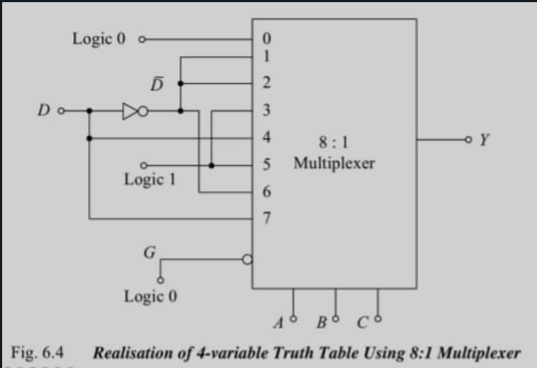

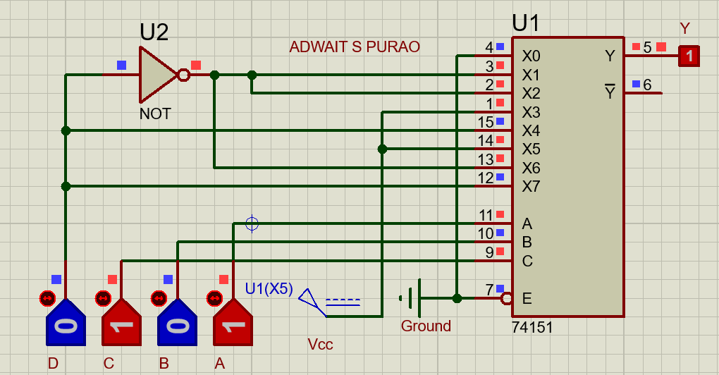

**Conclusion:**